Project 1 Written Summary

Brock Hoover

February, 03, 2025

Table of Contents
Heading 1 3
Heading 2 3
Heading 3 5

Project IntroductionS
For this project, which is being submitted to Dr. Lane for the client of the UNMC Water, Climate and Health Group, we used a provided .csv file that was given to us by the client. The .csv file includes data from Air Purple Monitors in the state from February 2024 to March 2025.

For this project, the project team was tasked with finding the five locations in Nebraska with the highest mean and median concentrations of VOC, PM 2.5, and PM 10.0. When and where the maximum values occurred, and whether humidity, altitude, or temperature affected sensor readings.

Mean and Median Concentrations of VOC, PM2.5 and PM10.0
To find the mean and median concentrations of VOC, PM2.5 and PM10.0. The mean and median concentrations were grouped by the sensor name and aggregated by the mean and median. Generative AI was used with the Google Gemini Pro 3 model to fix an issue with the code where it wasn’t grouping together the days, the Gemini output and the code that was used can be seen in Figure 1 and Figure 2.
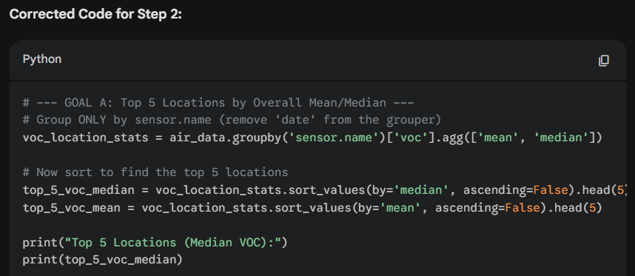
Figure 1, Gemini code output for how the code could be improved.
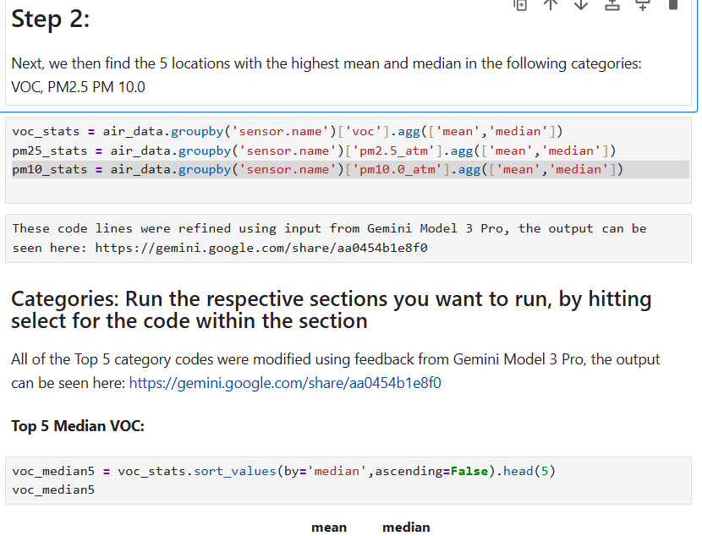
Figure 2, how the code was implemented into the project. Top 5 for each category was done differently from Gemini
For the tables, the results can be seen in Table 1, Table 2, Table 3, Table 4, Table 5, and Table 6. The VOC is consistent between the mean and median, while the PM2.5 and PM10.0 data is far more inconsistent. This will be investigated later in the report, as this indicates a surprising amount of variability with the data.

Table 1, Top 5 Median VOC
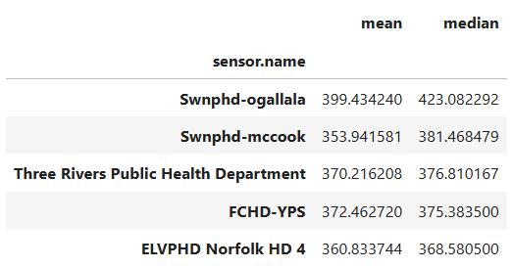

Table 2, Top 5 Mean VOC
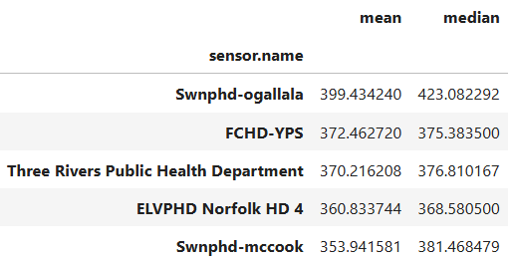

Table 3, Top 5 Median PM 2.5
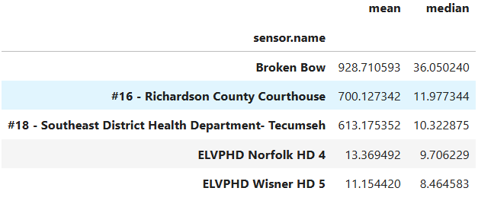

Table 4, Top 5 Mean PM 2.5
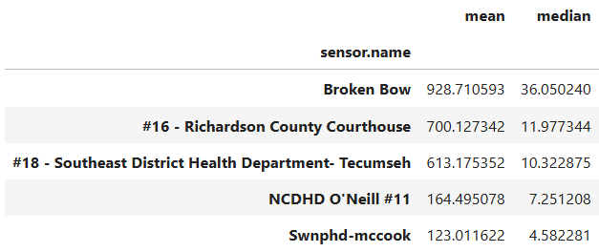

Table 5, Top 5 Mean PM 10.0
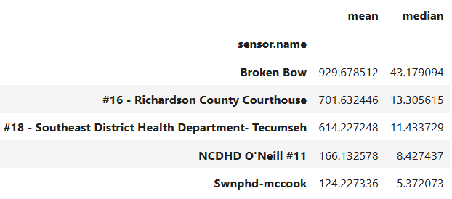

Table 6, Top 5 Median PM 10.0
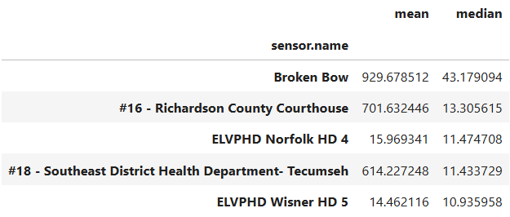

Maximum Values in Data Set:
It was requested that the maximum values be found for each category, and what day and location those values occurred. This can be seen in Figure 3.
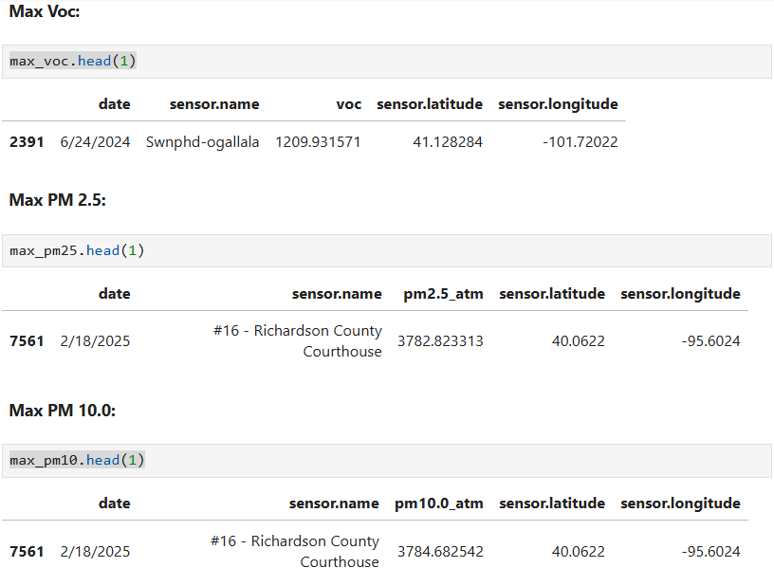
Figure 3, Max VOC, PM 2.5 and PM 10.0 Values

Temperature, Humidity, and Altitude Categorization:
Temperature, Humidity, and Altitude were asked to be categorized, how that was done in the code can be seen in Figure 4, Figure 5, and Figure 6.
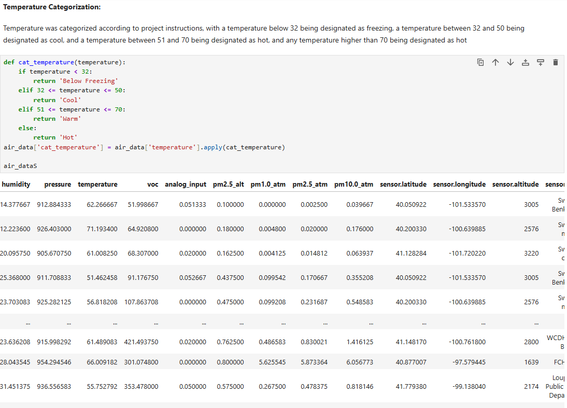
Figure 4, temperature code process and output
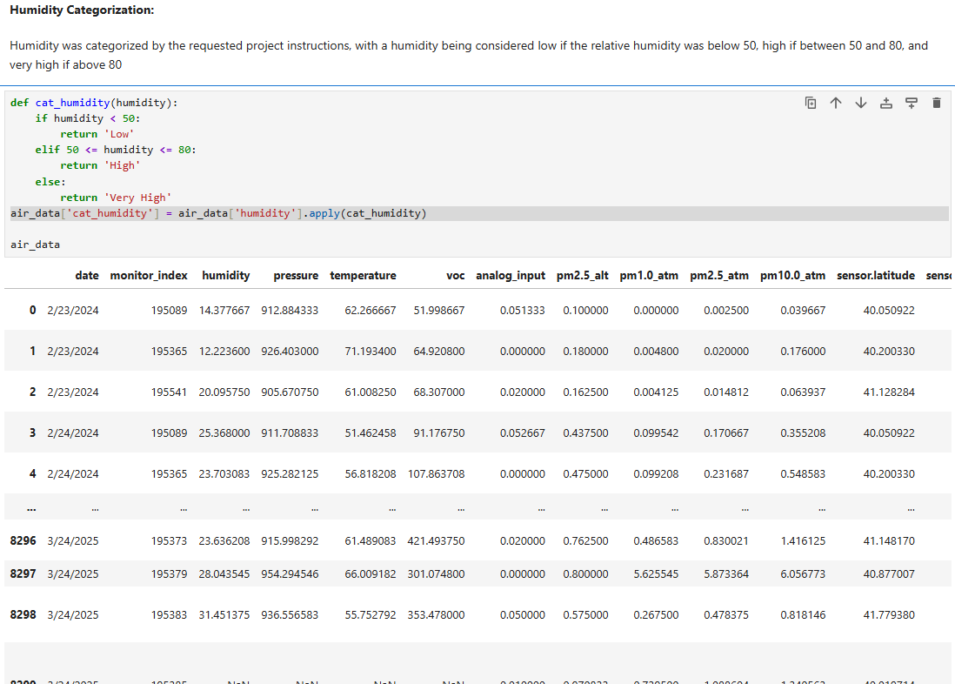
Figure 5, Humidity code process and output
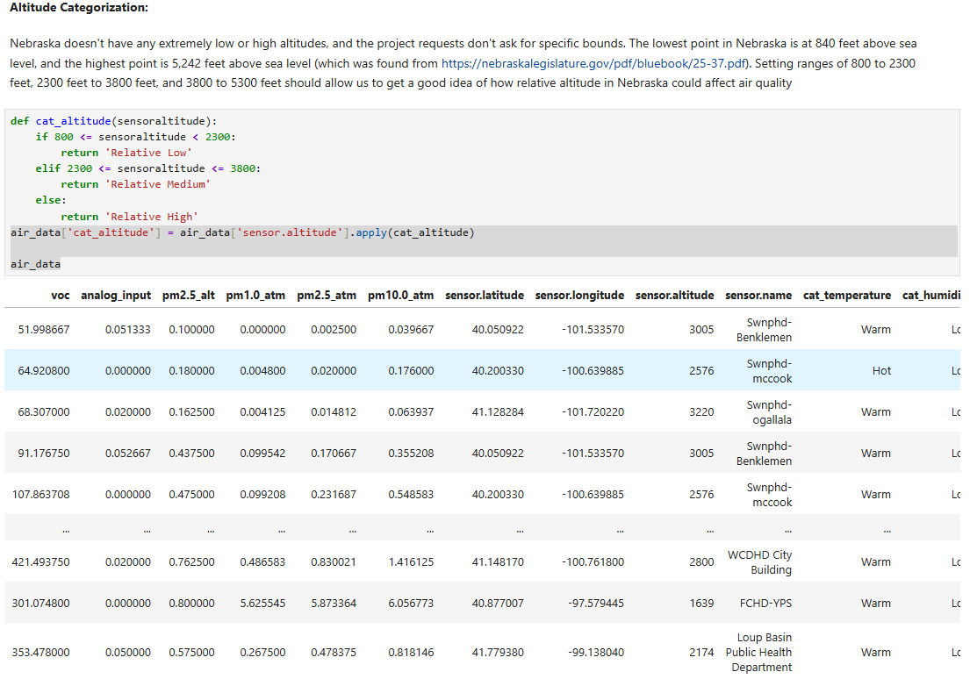
Figure 6, Altitude Code and Output.

Combining data and analyzing results:
After find the temperature data, ranges were used based on EPA AQI numbers for PM2.5 and PM 10.0 numbers for unhealthy populations. The highest 50 results were then looked at for PM 10.0 and PM 2.5. This can be seen in Figure 7
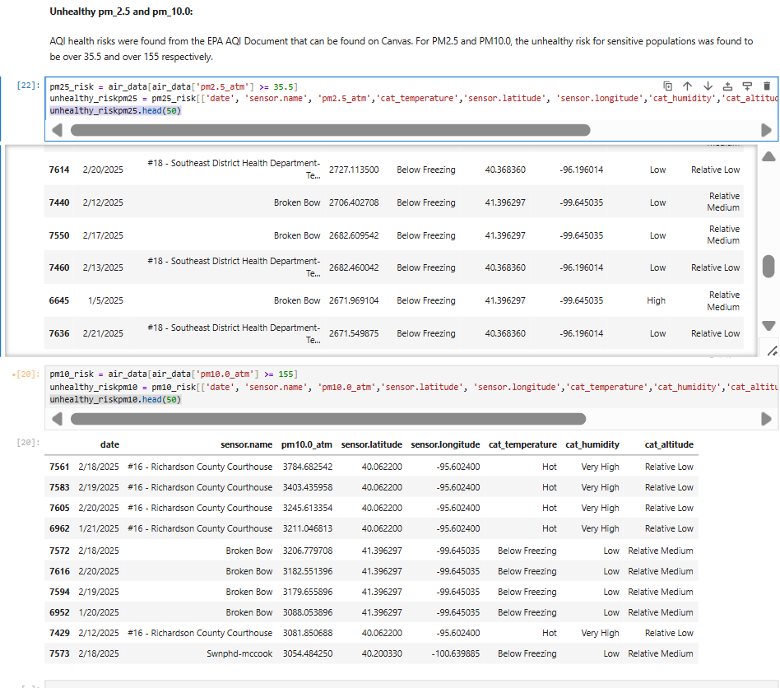
Figure 7, Combined Data Output

Data analysis:
For the high VOC values in Ogallala, the project team was unable to identify any specific causes, and as such, doesn’t have any recommendations. There is some reference by the EPA to a superfund site near a dry cleaner in the city, but this was a long time ago, and given how common dry cleaners are, I doubt this one was so bad that it caused Ogallala to have high VOC levels compared to the rest of the state

Temperature and Humidity were categorized into client specified ranges, and the only correlation was that humidity and temperature that is on the extreme ends (either below freezing or hot, or low humidity and high humidity) did impact the sensor readings.

The project team advises that this data from the PurpleAir sensors isn’t useable for the applications that UNMC wants to identify from it without further data investigation and trimming of data. Forum posts on the PurpleAir forum indicate that data levels this high are a result of a malfunctioning sensor, and not indicative of any possible weather events, which was noted by a response by forum staff member Andrew in a post created by user bluesystems

References:
bluesystems. "Sensor Reading 2375." PurpleAir Community, 9 June 2023, community.purpleair.com/t/sensor-reading-2375/4851.

"Conversation with Gemini." Gemini, Google, 3 Feb. 2026, gemini.google.com/app/270091a4c43baecc.

United States Environmental Protection Agency, Office of Air Quality Planning and Standards. Technical Assistance Document for the Reporting of Daily Air Quality - the Air Quality Index (AQI). EPA 454/B-18-007, Sept. 2018.

United States Environmental Protection Agency, Office of Solid Waste and Emergency Response. Optimization Review: Ogallala Ground Water Contamination Superfund Site, Operable Unit 2 (Tip Top Cleaners), Ogallala, Nebraska. 16 Jan. 2013, 19january2021snapshot.epa.gov/sites/static/files/2015-06/documents/fnlrseogallala.pdf.

